EXPERIMENT:13: Demonstrate Infrastructure as a Service (IaaS) by creating a Virtual Machine using a Public Cloud Service Provider (Azure), configure with required memory and CPU.

STEP:1:: GO TO THE CREATE AND SELECT THE AZURE VIRTUAL MACHINE.

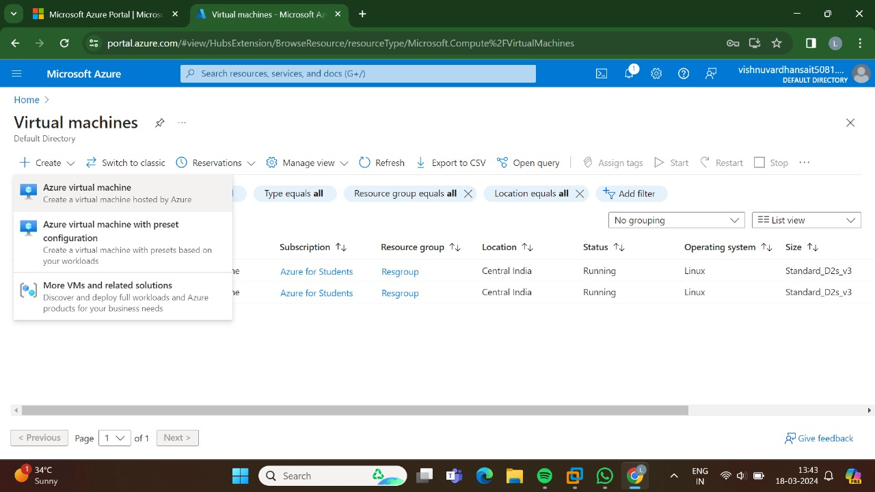

STEP:2: AND THEN TYPE THE BASICS.

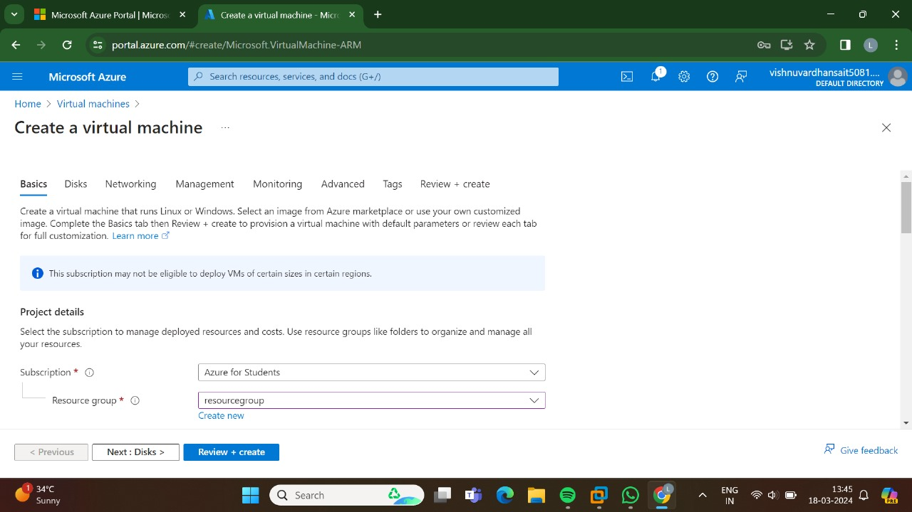

STEP:3: AND THEN GO TO THE DISKS.

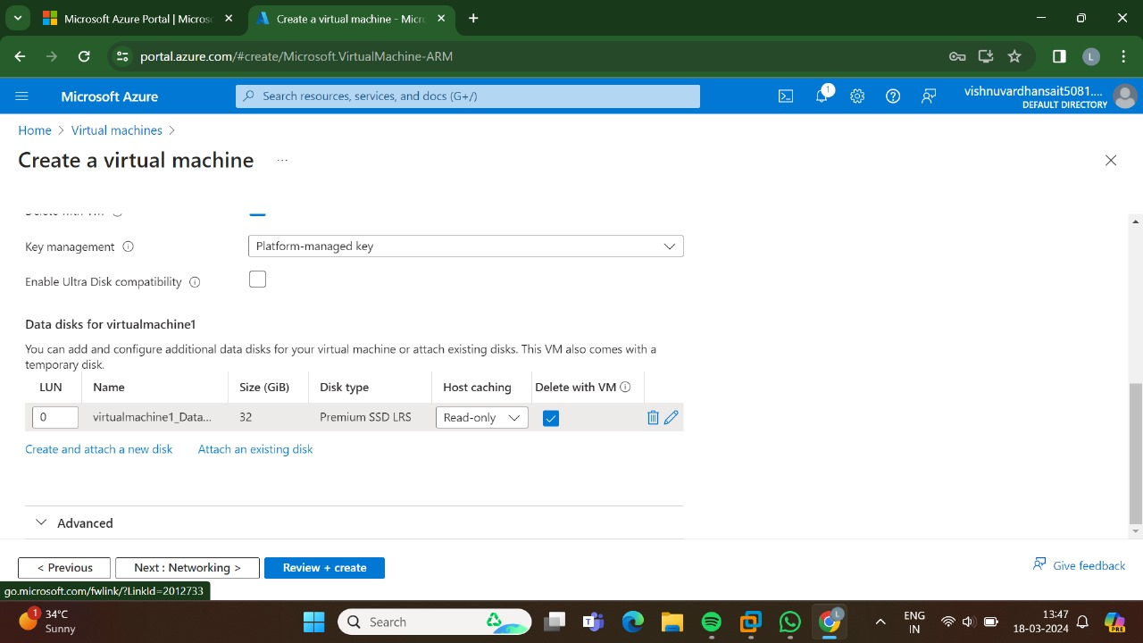

STEP:4: AND THEN GO TO THE NETWORKING.

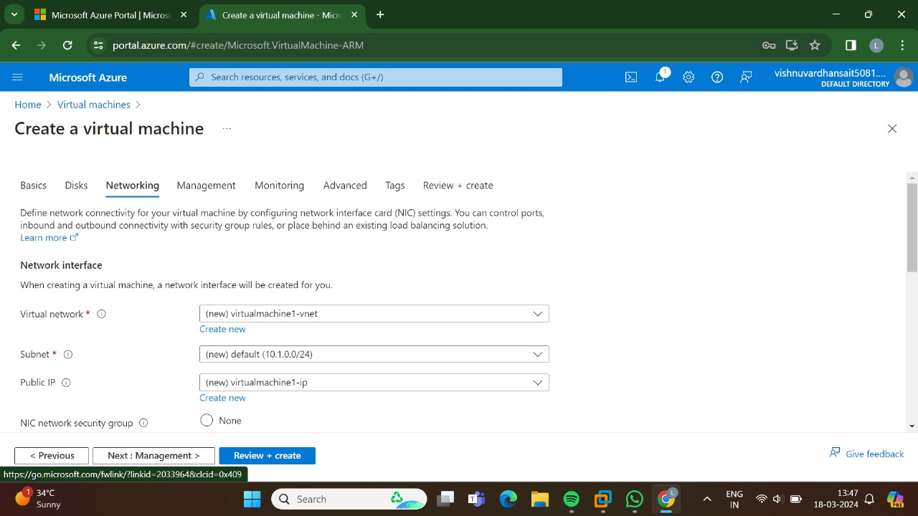

STEP:5: AND THEN GO FOR THE MANAGEMENT.

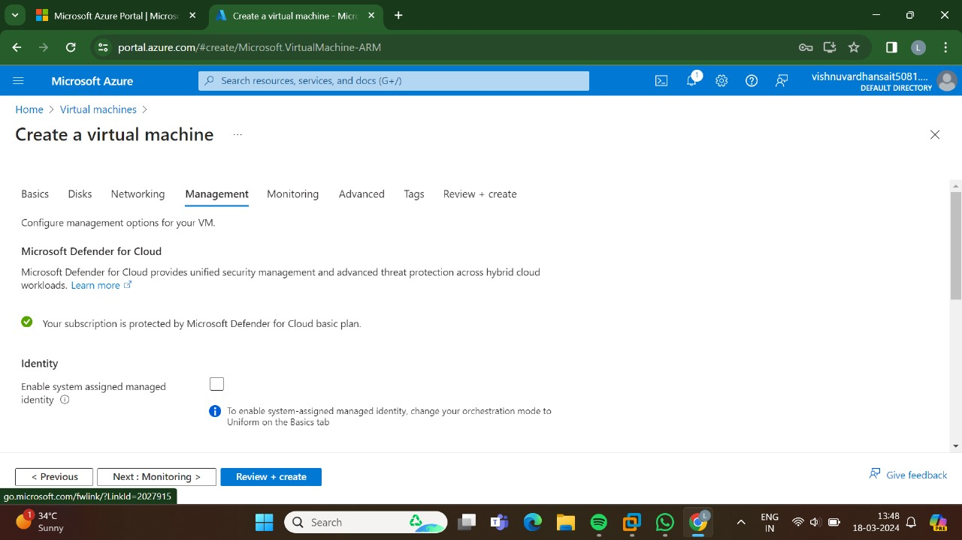

STEP:6:: AND, THE GO FOR THE MONITORING.

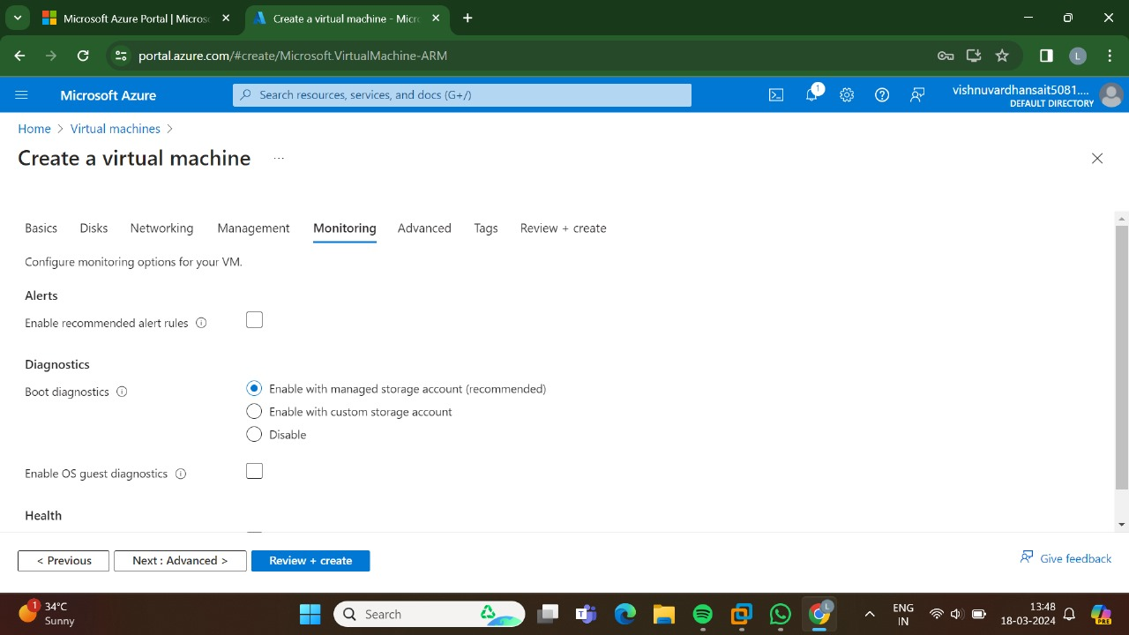

STEP:7:: AND THEN GO FOR THE ADVANCED.

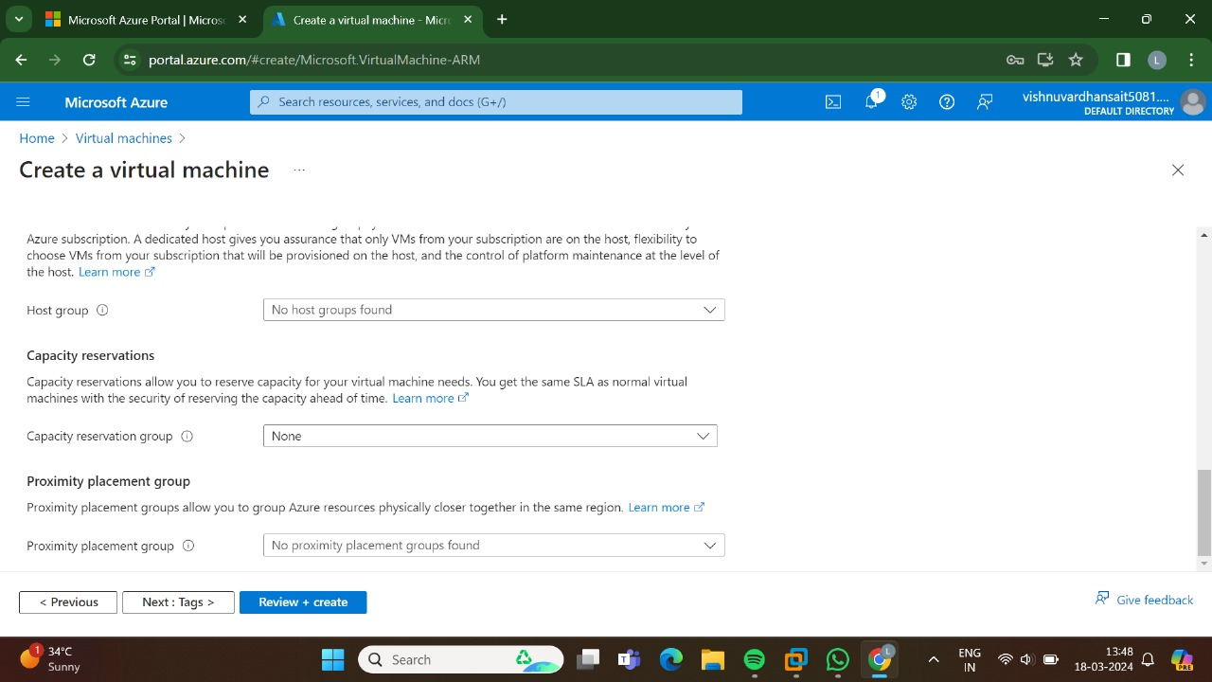

STEP:8:: AND THE GO FOR THE TAGS.

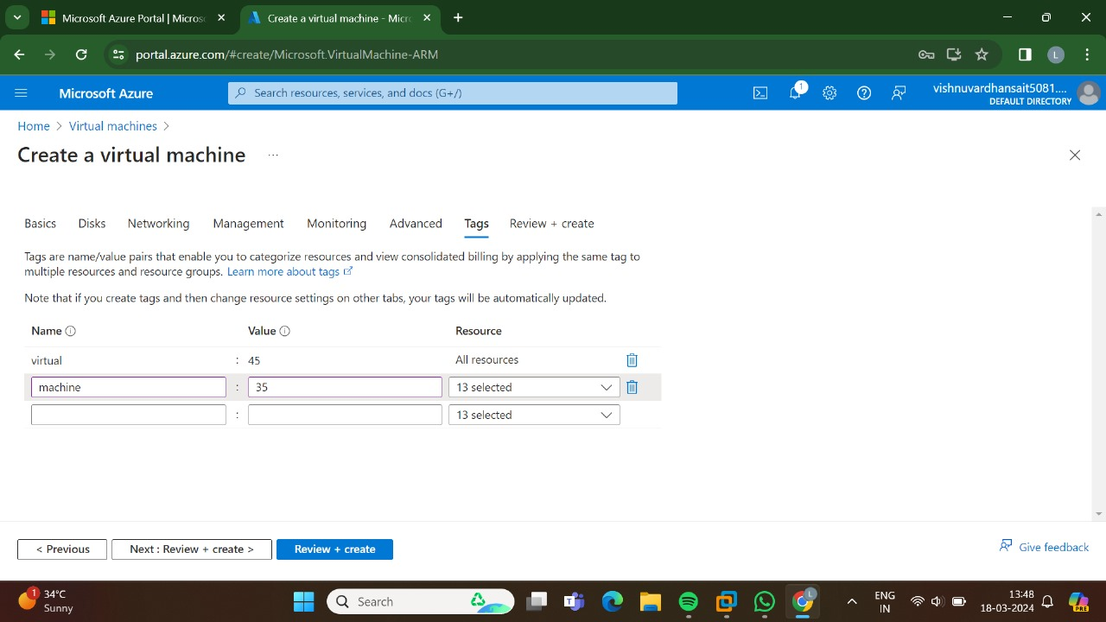

STEP:9: AND THEN AT LAST GO TO THE REVIEW+CREATE AND THEN SELECT THE CREATE.

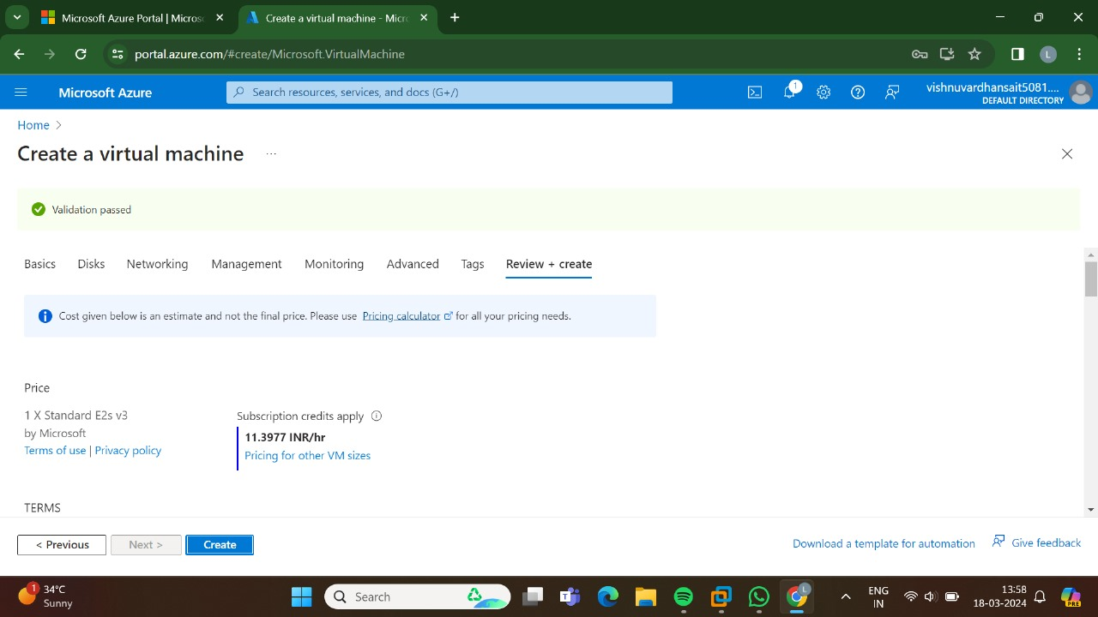

STEP:10: THE DEPLOYMENT IS IN PROCESS.

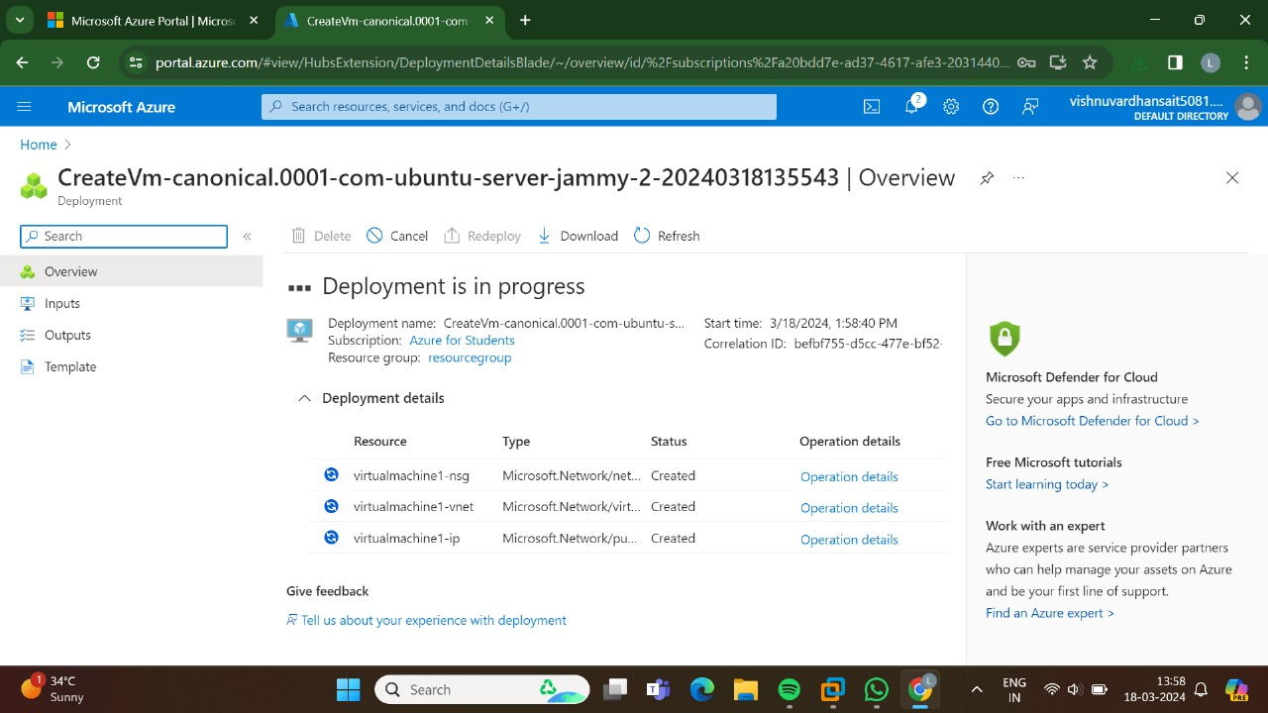

STEP:11: HENCE, THE DEPLOYMENT IS SUCCESSFUL.

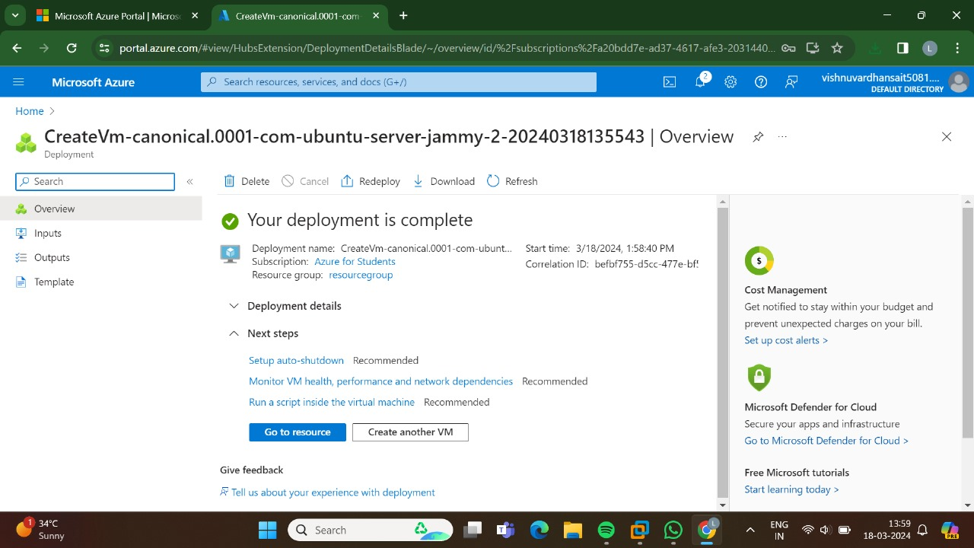

RESULT: THUS,THE PROGRAM FOR THE VIRTUAL MACHINE IN AZURE HAS BEEN DONE SUCCESSFULLY.